xpedx.com Next Generation
Technical Design Specification – Customer Batch Process

Authors: | Sterling Commerce
Version: | 0.1
Date Created: | 4/13/2010
Last Updated:

Document Revision History
Revision | Date | Description | Author
0.1 | 03/08/2010 | Draft | Sterling Commerce

Document Approval History
Name | Signature | Date | Version Approved/Comments

Reference Documents
Document Name | Description | Owner | Location
SCI_Xpedx Solution Definition Document v1.0 | Solution Definition document | Sterling Commerce

Table of Contents
1. Introduction 4
1.1. Purpose 4
1.2 Nomenclature 4
1.3 Performance Considerations 4
2. Technical Components 4
2.2 Components Overview 4
2.3 Component Design 4
2.3.1 Design for xpedxAsynchLoadItemMaster 4
2.3.2 UI Design 5
2.3.3 UI Validations 5
2.3.4 Input Document 5
2.3.5 Output Document 5
2.3.6 Configuration 5
2.3.1.1. <Insert Sub-Component Name> 6
3. Database Extensions 7
4. Exception and Error Handling 7
5. Security Aspects 7
5.1 Ownership 7
5.2 Encryption 7
5.3 Audit Trail 7
5.4 Other Security Aspects 7
6. Dependencies 7
7. Unit Test Cases 8
7.1 <Insert Component Name> 8

1. Introduction

Purpose
- XReference Section 1.1 – Document Purpose in Functional Design Document
2. UI ref to HLD, if HLD has the UI details.

1.2 Nomenclature
<Glossary of terms - list only new terms applicable to this design>

Term | Description
CSR | Customer Service Representative
P&A | Price and Availability

1.3 Performance Considerations
List of all the factors that impact performance

2. Technical Components

2.1 Components Overview

The Customer batch feed service is used to build the Customer hierarchy from legacy system to sterling. This component reads the input xml and generates the hierarchy according to the input xml.

2.2 Component Design

- xpedxUpdateCustomerBatchProcessService

- 2.2.1 Design for xpedxUpdateCustomerBatchProcessService

2.3.2 UI Design
<This section is applicable to UI components. Provide a UI mockup and elaborate the design for UI>N/A

2.3.3 UI Validations
<This section is applicable to UI components. Provide the various validations that need to be applied for each field/control on the UI mock-up>N/A

2.3.4 Input Document
<CustomerList>
<Customer
EnvironmentId=""
CompanyCode=""
ProcessCode="Modify"
CustomerDivision=""
LegacyCustomerNumber=""
SuffixType=""
ShipToSuffix=""
BillToSuffix=""
CustomerOrderBranch=""
ShipFromBranch=""
CustomerStatus=""
CustomerName=""
BrandCode=""
CustomerClass=""
ServiceOptimizationCode=""
CurrencyCode=""
InvoiceDistributionMethod=""
NationalAccountNumber=""
SAPNumber=""
SAPParentAccountNumber=""
ShipComplete=""
OrderUpdateFlag=""
CapsId=""
>
<AddressList>
<Address AddressLine1="" AddressLine2="" AddressLine3="" City="" State="" Country="" ZipCode=""/>
</AddressList>

<SalesReps>
<SalesRep EmployeeId="CSR1"/>
<SalesRep EmployeeId="CSR2"/>
</SalesReps>
</Customer>
</CustomerList>

2.3.5 Output Document

<Customer CustomerID="BUYER1_C2" CustomerLevel="" CustomerType="01"
IgnoreOrdering="Y" OrganizationCode="HM" RelationshipType=""
Status="" Vertical="">
<Extn ExtnBrandCode="" ExtnCAPSID="" ExtnCustOrderBranch=""
ExtnCustomerClass="" ExtnCustomerDivision=""
ExtnInvoiceDistMethod="" ExtnLegacyCustNumber=""
ExtnNationalAccNo="" ExtnOrderUpdateFlag=""
ExtnPrimarySalesRep="" ExtnSAPNumber="" ExtnSAPParentAccNo=""
ExtnServiceOptCode="" ExtnShipComplete="" ExtnShipFromBranch="" ExtnSuff
ixType="">
<XPEDXSalesRepList>
<XPEDXSalesRep Operation="Create" SalesRepId="CSR4"/>
<XPEDXSalesRep Operation="Create" SalesRepId="CSR3"/>
</XPEDXSalesRepList>
</Extn>
<ParentCustomer CustomerID="BUYER1_HM" OrganizationCode="HM"/>
<BuyerOrganization DunsNumber="" IsBuyer="Y" LocaleCode="en_US_EST"
OrganizationName="BUYER1_CHILD2" ParentOrganizationCode=""
PrimaryEnterpriseKey="xpedx" PrimaryUrl=""/> <BillingPersonInfo AddressLine1="" AddressLine2="" AddressLine3=""
City="" Country="" State="" ZipCode=""/>
<ContactPersonInfo AddressLine1="" AddressLine2="" AddressLine3=""
City="" Country="" State="" ZipCode=""/>
</Customer>

2.3.6 Configuration
Create service xpedxCustomerBatchProcessService

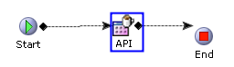

Properties: API
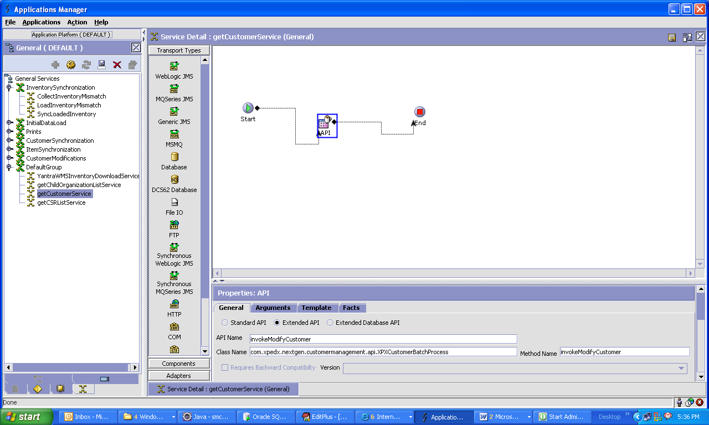

2.3.1.1. <Insert Sub-Component Name>
<Elaborate input and output of each sub-component if applicable>N/A

- Input Document

- Output Document

3. Database Extensions
<Provide the database extensions required for the component in the format provided below. The data types need to be clearly specified. Always Out-of-the-box data types should be reused. If a data type for the given combination doesn’t exist, a new data type name should be specified>

<Database Extension Template>
Table Name |  | YFS_CUSTOMER
Overview
Extensions/Custom/Hang-off |  | Extensions
Primary Keys
Index on
Attribute Name | Column Name | Data Type/Size | OOB Data Type Name | Default Value | Description
ExtnCustomerDivision | EXTN_CUSTOMER_DIVISION |  | OrgCode | ‘ ‘ | The ship node
ExtnLegacyCustNumber | EXTN_LEGACY_CUST_NUMBER |  | AccountNo | ‘ ‘ | Account Number
ExtnSuffixType | EXTN_SUFFIX_TYPE |  | Text-2 |  | ShipTo or BillTo
ExtnCustOrderBranch | EXTN_CUST_ORDER_BRANCH |  | OrgCode |  | Customer Order Branch
ExtnShipFromBranch | EXTN_SHIP_FROM_BRANCH |  | OrgCode |  | Ship From Branch
ExtnBrandCode | EXTN_BRAND_CODE |  | Text-2 |  | Brand Code
ExtnCustomerClass | EXTN_CUSTOMER_CLASS |  | ProductClass |  | Customer Class
ExtnServiceOptCode | EXTN_SERVICE_OPT_CODE |  | Text-25 |  | Service OPtimization Code
ExtnInvoiceDistMethod | EXTN_INVOICE_DIST_METHOD |  | Text-25 |  | Invoice Distribution method
ExtnNationalAccNo | EXTN_NATIONAL_ACC_NO |  | AccountNo |  | National Account Number
ExtnSAPNumber | EXTN_SAP_NUMBER |  | Text-25 |  | SAP Number
ExtnSAPParentAccNo | EXTN_SAP_PARENT_ACC_NO |  | AccountNo |  | SAP Parent Account Number
ExtnShipComplete | EXTN_SHIP_COMPLETE |  | Text-25 |  | Ship Complete
ExtnOrderUpdateFlag | EXTN_ORDER_UPDATE_FLAG |  | Flag |  | Order Update Flag
ExtnCAPSID | EXTN_CAPS_ID |  | Text-25 |  | CAPS ID
ExtnPrimarySalesRep | EXTN_PRIMARY_SALES_REP |  | UserId-40 |  | Primary sales rep

Table Name | XPEDX_SALES_REP
Overview
Extensions/Custom/Hang-off | Custom
Primary Keys | SalesRPKey
Index on
Attribute Name | Column Name | Data Type/Size | OOB Data Type Name | Default Value | Description
SalesRPKey | SALES_RP_KEY |  | Key | ‘ ‘ | Sales Rep Key Primary key of this table
SalesRepId | SALES_REP_ID |  | UserId-40 | ‘ ‘ | SalesRep Id
SalesUserKey | SALES_USER_KEY |  | Key |  | User Key
SalesCustomerKey | SALES_CUSTOMER_KEY |  | Key |  | Customer Order Branch

4. Exception and Error Handling
This component will throw an InvalidCategory exception if the category to which the item is to be attached has not been created.
<Provide the list of exceptions (business and system exceptions) the component can throw>

5. Security Aspects
<Provide details on the security aspects of this implementation. Where would these security components reside, what will be encryption that will be used and any audit trails required>N/A

5.1 Ownership
5.2 Encryption
5.3 Audit Trail
5.4 Other Security Aspects

6. Dependencies
<For issues that are dependent on customer: Record all dependencies made for this design including business requirement, performance and technical factors, etc. in JIRA and list the JIRA tickets numbers here

JIRA no | desc | To be validated by  (Team/Person) | Status | Implications if incorrect

<For issues those aren’t dependent on customer: Record all dependencies made for this design including business requirement,performance and technical factors, etc. here

Include only those that are not already documented in SDD If there are changes in SDD, reference the specific dependency and state the revised assumption. New assumption should be approved prior to design review> XReference Section 2.8 – Assumptions in Functional Design Document.

No. | Assumption | To be validated by  (Team/Person) | Status | Implications if incorrect

7. Unit Test Cases
<Elaborate unit test cases for all the components. Every unit test case should include description, pre-requisites, expected results, etc. The below section should repeat for each component>

7.1 <Insert Component Name>

Test No. | Test Description | Execution Instructions | Expected Result
1 | Pass the input customer list as mentioned in the input document above.(2.3.4) |  | 1) The record for each customer should be created in the YFS_CUSTOMER table.  2) Corresponding organization entry should be created in YFS_Organization.  3) The CSR records should be inserted into XPEDX_SALES_REP table.
2 | Test with ProcessCode as Create. |  | The records should be created
3 | Test With ProcessCode as Delete. |  | The records should be deleted.
4 | Test with ProcessCode as Modify. |  | The records should be updated.

